Fanny Bay Flyer FBSES column for August 2018; 425 words
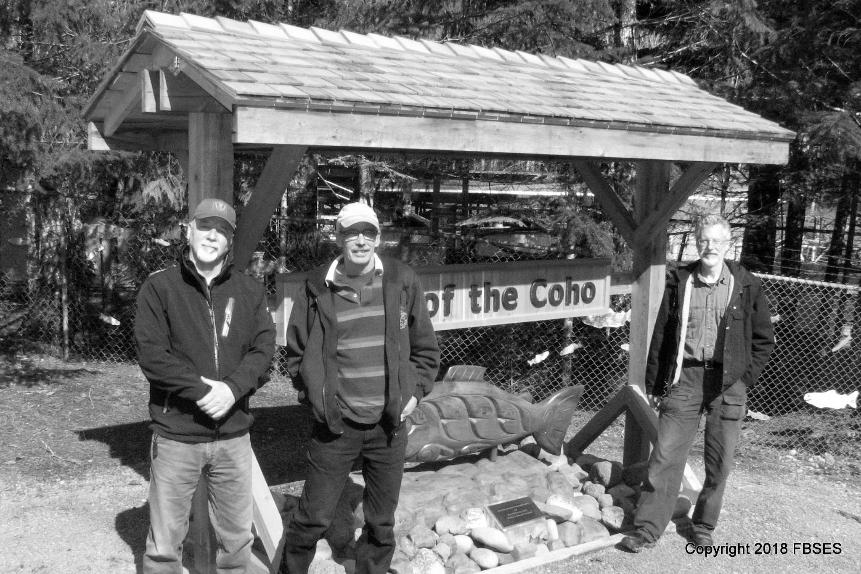
When you come to visit us at the FBSES hatchery you’ll know you are at the Home of the Coho because that’s what our big beautiful new sign says. It’s an impressive wood structure standing eight feet high and and spanning 12 feet and its shingle roof protects not only the sign but also the work of K’omoks First Nation carver Randy Frank whose five foot coho from a slab of old growth cedar is the centerpiece.
Designer of the sign and lead participant in its construction, which took an estimated one hundred hours, is volunteer Jens Johansen of Bowser. Other members who worked on it were Randy Lousier, Larry McDonald and Tom Hutton of Fanny Bay. Jens and wife Wendy have been FBSES members since 2014 after coming to the island from Edmonton.
Water is one of our preoccupations in the summer months. Going from too much water to not enough means changing water sources from Rosewall Creek to deep aquifer wells. It also means juggling water temperatures; stream water is variable. In mid July it was 15.5 degrees C, but the well water was about 10.5 C and the difference is too much for our fish, so water has to be blended for temperature, while being balanced in quantity because the supply is dropping (from Rosewall) and limited, from the wells—we have an allotted amount to work with. Rosemary Sparham is one of FBSES’ fish culturists and she gets to do the juggling, which involves some heavy lifting, since waterlines, wells, water towers and tanks full of fry are all in the air in this act.
The shortage of water is real for the wild fish too, as Rosewall Creek starts to vanish into its stream bed. McNaughten and Cook creeks have already gone dry. FBSES now has 5455 fish from those two, 366 just in from Rosewall, and 10,400 from Hart-Washer and Emily and Hindoo creeks near Union Bay in 14 tanks . Being salvaged doesn’t just save the lives of these wild salmon, it really improves their lifestyle. One random example; from July to October 2017 the average weight of a wild fry went from 1.17 grams to 3.87 for the 1017 Cook fish in tank A-9. Regular meals, no predators and cool, clear water will do a lot for you that way.
You can visit these fat and happy little guys every Wednesday and Saturday at our work parties, and we have coffee and cookies at break time. Average weight gain of FBSES members is not available. Our non-fattening website is www.fbses.ca

